**A1: Niagra Falls**

## 13 Things To Do In Niagara Falls, Canada

While there are numerous places to visit and **fun things to do in Niagara falls** that can be done near and around the Niagara Falls area, some are more interesting, as per our analysis. Here is a list of 10 Best Activities to do near Niagara Falls:

* **The Horseshoe Falls**
* **Niagara Falls Boat Tour**
* **Maid Of The Mist Tour**
* **The Old Fort Niagara**
* **The Niagara Aquarium**
* **Castellani Art Museum**
* **White Water Walks**
* **Helicopter Ride**
* **Journey Behind The Falls**
* **Niagara Falls View Casino**
* **Clifton Hills**
* **Butterfly Conservatory**
* **Botanical Garden**

### 1. The Horseshoe Falls

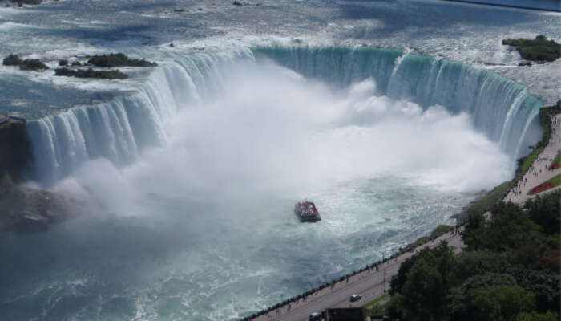

[Image Source](https://commons.wikimedia.org/wiki/File:Aerial_view_of_the_Canadian_Falls_(Horseshoe_Falls)_and_the_Hornblower_Niagara_Cruises_boat;_Niagara_Falls.JPG)

This is the largest waterfall in North America. Standing at an impressive 2200 feet in width and about 188 feet in height, it is almost double the size of the other waterfalls which make the Niagara Falls. Almost 90% of the water from river Niagara flows through this waterfall. The northeastern part of the waterfall lies in New York while the rest of it lies in Ontario, [Canada](https://traveltriangle.com/canada-tourism). This is one of the best Niagara falls activities.

### 2. Niagara Falls Boat Tour

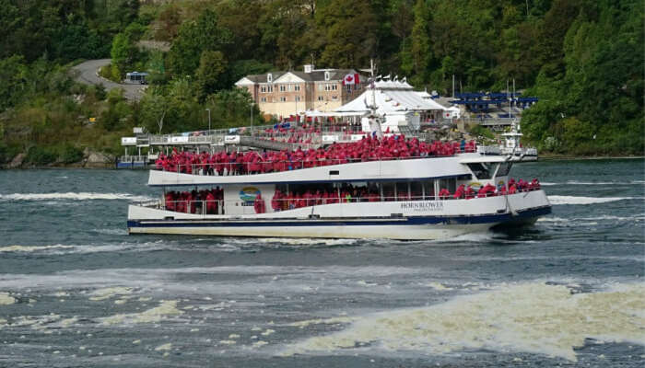

[Image Source](https://pxhere.com/en/photo/843608)

Get onboard the iconic Hornblower Catamaran and experience the awe-inspiring beauty of the Niagara Falls. The state-of-the-art 700-seater Niagara Thunder and Niagaran Wonder boats will take you to this awe-inspiring natural wonder. This is a main attraction of the Niagara Falls and has been attracting visitors for over 170 years.

### 3. Journey Behind The Falls

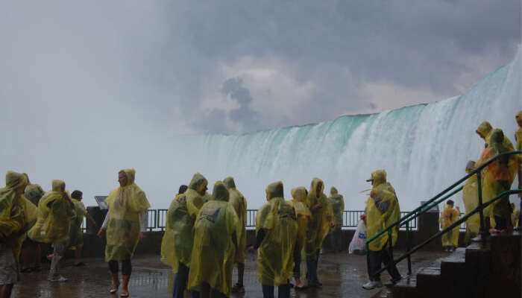

[Image Source](https://te.wikipedia.org/wiki/%E0%B0%A6%E0%B0%B8%E0%B1%8D%E0%B0%A4%E0%B1%8D%E0%B0%B0%E0%B0%82:Journey_Behind_The_Falls_Niagara_Falls04.JPG)

Journey Behind the falls gives you a chance to stand directly behind the roaring white waters of the Niagara Falls. Begin with an elevator ride to the observation deck behind the Horseshoe and American Falls, then follow the caverns and experience the spectacular scenes of roaring waters from many different angles. Journey Behind the Falls is the most popular way to experience the waterfalls, way better than the cramped up tunnels.

**A2: Events at Casa Loma**

**Attractions & Things to do at Casa Loma**

Go on a self guided Audio Tour and explore Canada’s foremost castle: Tour the rooms decorated in period furnishings, step into secret passages and climb up the winding stairs to the top of the majestic tower for a great view of Toronto landscape.

Follow the 800 foot underground tunnel that connects Casa Loma to the stables and the hunting Lodge. The Tunnel starts in the lower level, entrance is near the gift shop.

Tour the landscaped 5 acre estate gardens complete with art installations and water features.

[Escape the Tower:](http://www.escapecasaloma.com/) Try out Escape Games based on true historical facts at the Tower that blends fact with fiction and theatre with gaming.

Enjoy symphony series by the renowned Toronto Concert Orchestra at Casa Loma. Various events like [Easter Brunch](https://www.todocanada.ca/city/toronto/event/easter-brunch-casa-loma/)/Mother’s Day/[Father’s Day BBQ](https://www.todocanada.ca/Fathers+Day+BBQ+at+Casa+Loma/) , Canada Day BBQ, and exhibitions are also held at Casa Loma.

Learn more about Sir Pellat through the 20 Minute Historic Documentary, *Pellatt Newsreel: The Story of a Lifetime. D*on’t miss the antique cars, the Darkside installation, and the art exhibit on the 3rd floor!

You can also hold [private functions](http://www.casaloma.org/venue_rentals_catering.index.gk)(venue rental) like weddings and parties at Casa Loma.

**A3: Gros Morne National Park Activities**

The Tablelands:

Don’t miss the internationally known Tablelands, a rare outcrop of the Earth’s mantle pushed skyward half a billion years ago. Explore on your own with the Explora app on your phone. How do you want to see the Earth Naked?!?

Cruise the freshwater fjord of Western Brook Pond

An easy walk past natural bog and forest leads to the dock for a scenic boat trip up Western Brook Pond, cruising the base of sheer cliff walls where waterfalls tumble, to the end of the freshwater fjord.

Lobster Cove Head Lighthouse Exhibit

The Lobster Cove Head Lighthouse has always been a place of gathering for coastal people of Newfoundland. Explore this historical lighthouse, partake in coastal adventures and enjoy seaside walks or a picnic with a view at Lobster Cove Head.

Trek to the panoramic views atop Gros Morne Mountain’s summit

Trek to the top of Gros Morne Mountain, the park’s high point, on a challenging, one-day, 16-kilometre loop. Hike from lowland to alpine terrain amid wildflowers and wildlife, enjoying panoramic views from the summit.

**A4: Quebec-city Activities:**

ATV and Quad

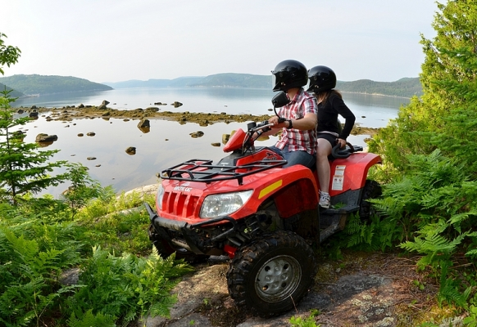

Take on that beaten path on an ATV or quad, on Quebec’s extensive trail network. Off-road gurus are sure to love practising their favourite outdoor activity in Quebec. Guided or not, make your next ATV adventure simply unforgettable by choosing between different getaway plans tailored to meet to your every need.

Cani-kart

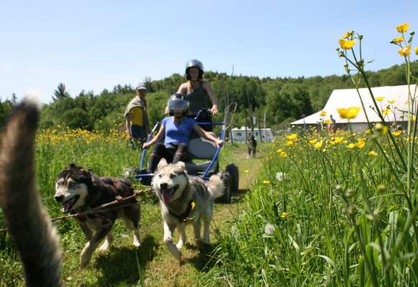

The dog sled calls you and there is no snow in sight? Try the cani-kart! Cani-kart is a wheeled sport with husky dogs, perfect for thrills that resemble dog sledding in any season. The cani-kart is also perfect for training dogs in preparation for the winter season. With sleds on wheel (cani-kart or cani-scooter) you can drive a team of dogs and run at full speed in the dedicated trails.

**Fatbiking**

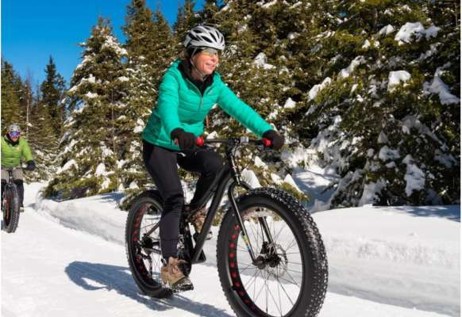

Known for its fat tires that are great on snow, fatbiking is on the rise across Quebec’s snow-covered landscape. A great outdoor activity on rugged terrain and assorted surfaces, hard-core mountain bikers are familiar this new sport’s every secret. Oversized tires make it easy to ride on snow, ice, through mud or sand. Greatly appreciated by fatbike gurus as well as novices too, the bike is specially designed for riding on snow. Certain outfitters offer fatbike and mountain bike rentals.

**Dog sledding**

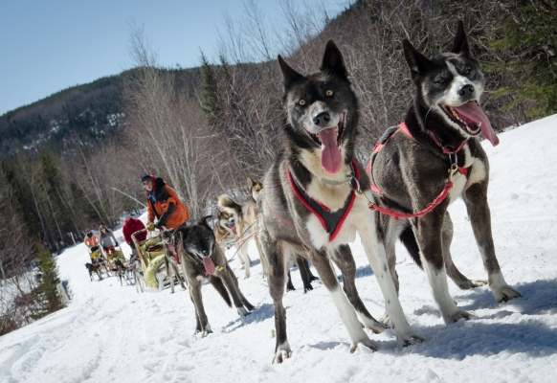

Live winter at its best ? in Quebec! Hop on a sled and let a husky or malamute team take you across the gorgeous frozen landscape. Experienced mushers drive you and your crew on a family outing across a network of sled trails, or anyone who prefers to sit back and enjoy this amazing outdoor experience to the fullest. The more adventurous are welcome to learn how to harness up their team, and mush too. Enjoy a moment of deep Nordic pleasure as you speed across the snow, by choosing the services of an Aventure Écotourisme Québec member dog-sled outfitter.

**A5: Banff National Park Activities:**

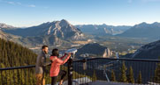

[Let us do the driving!](https://www.pc.gc.ca/en/pn-np/ab/banff/visit/parkbus/banff)

The best Banff National Park experience happens when you step out of your vehicle and explore the park.

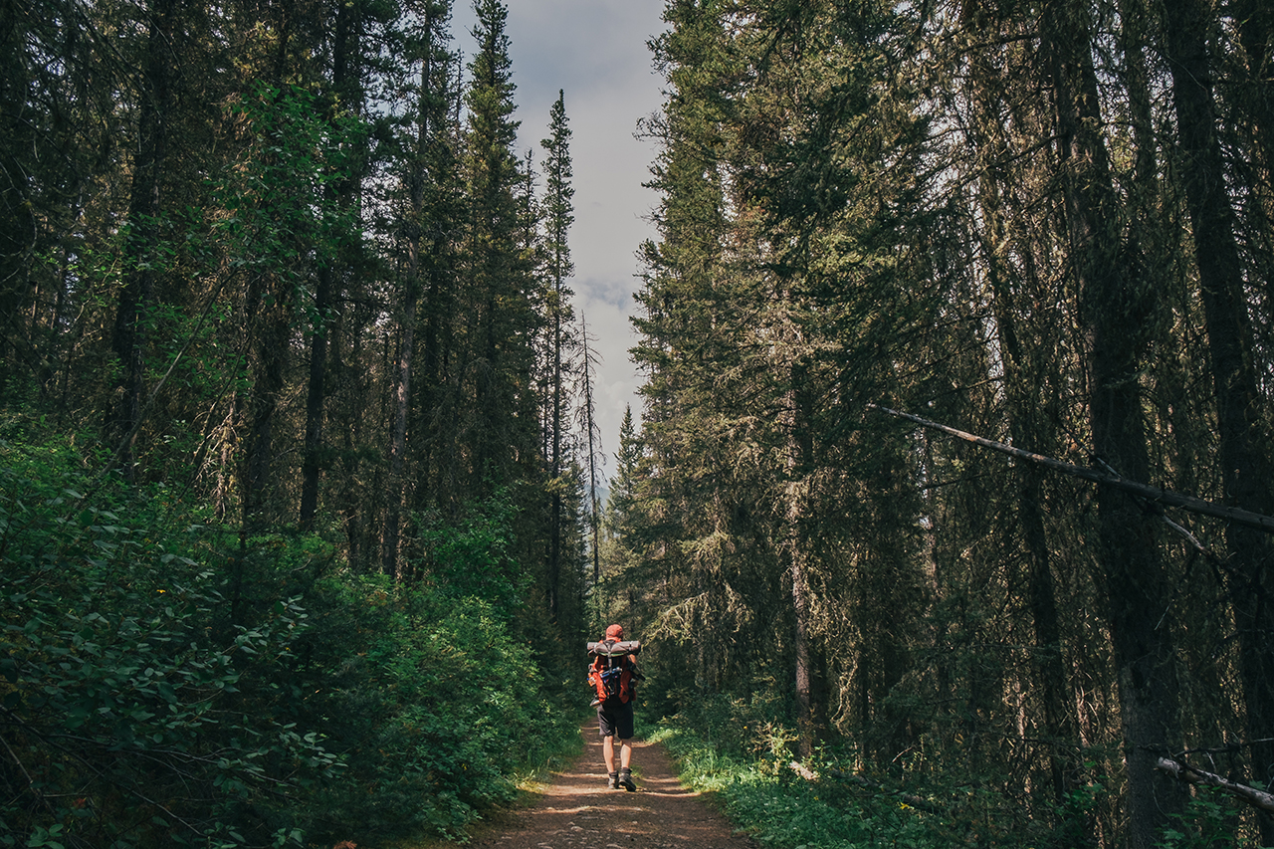

[Explore by foot on 1 600 km of maintained trails](https://www.pc.gc.ca/en/pn-np/ab/banff/activ/randonee-hiking)

Watch the sunset on a riverside stroll or feel the breath of glaciers in the alpine. Many of the park’s most famous hikes are easily accessible from the Town of Banff and the village of Lake Louise.

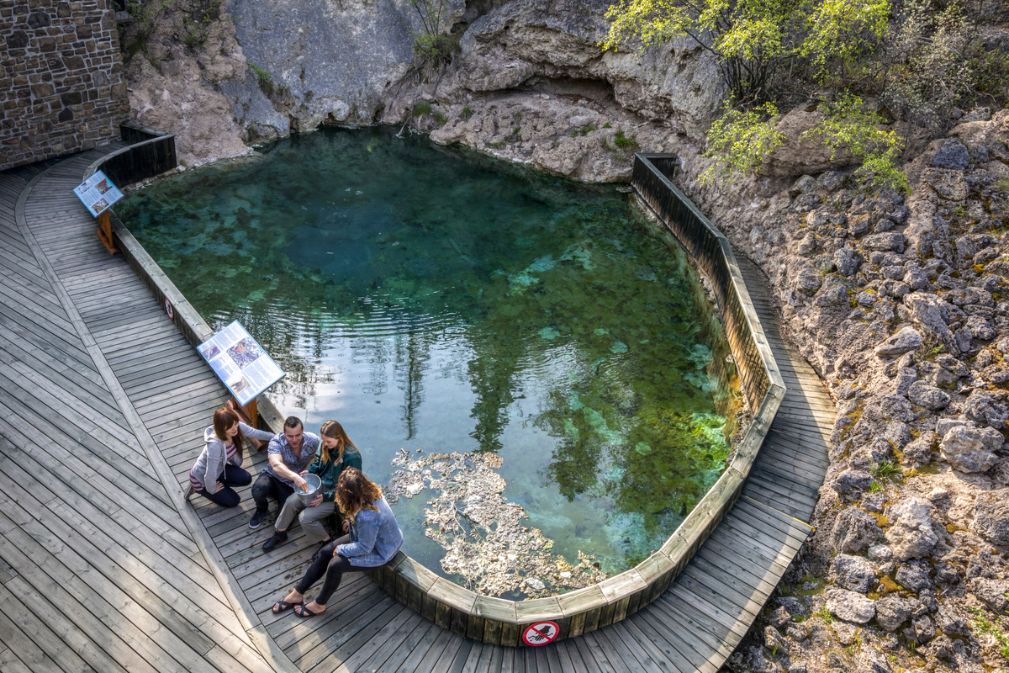

[Explore the birthplace of Canada’s national parks](https://www.pc.gc.ca/en/lhn-nhs/ab/caveandbasin)

When three railway workers stumbled upon bubbling hot springs in 1883, they had no idea it would lead to the creation of Banff National Park. Discover the birthplace of Canada’s first national park at Cave and Basin National Historic Site

**A6: Activities: Algonquin national park**

Backcountry Camping Campsite Accesspoint Backpacking

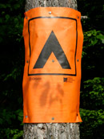Explore Algonquin at its best; a vast landscape of maple hills, rocky ridges, spruce bogs, and thousands of lakes, ponds, and streams. By paddle and portage - more than 2,000 kilometres of [canoe](https://www.algonquinpark.on.ca/visit/camping/backcountry-canoeing-in-ap.php) routes and over 1,900 campsites await those who seek the rugged beauty of Algonquin Provincial Park. Additionally, Algonquin has three[backpacking trails](https://www.algonquinpark.on.ca/visit/camping/backpacking-in-algonquin-park.php) which also probe the heart of the backcountry.

Because of the popularity of Algonquin, the Park's backcountry, it is often full on long weekends during July and August. In order to remove any uncertainty about being able to camp at the time and place you are counting on, we recommend that a [reservation](https://www.algonquinpark.on.ca/visit/camping/backcountry-reservations.php) be made in advance of your trip.

# Snowmobiling

Snowmobiling is not permitted within Algonquin Park with the exception of the hydroline across Clyde & Bruton Townships or with the written permission of the Park Superintendent.

For more information about snowmobiling in Ontario and the Round Algonquin Park (RAP) Tour check [Ontario Federation of Snowmobile Clubs](http://www.ofsc.on.ca/) or the [Hill & Gully Riders Snowmobile Club](http://www.hgrsnowmobileclub.on.ca/ride-the-rap.html).

[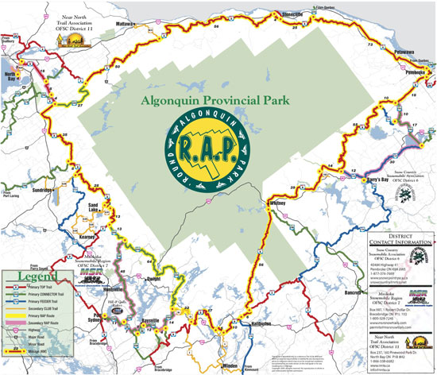](https://www.algonquinpark.on.ca/pdf/map_snowmobileRAPmap.pdf)

# Whitewater Canoeing Accesspoint

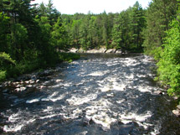Algonquin Park is located on a height of land known as the "Algonquin Dome". This positioning results in the headwaters of six major rivers that flow to Georgian Bay and St. Lawrence River (via the Ottawa River or Lake Ontario) originating in the Park. As a result whitewater canoeing is a popular recreational activity or vacation opportunity.

#### This activity can be dangerous or deadly for the inexperienced.

### The most popular whitewater rivers in Algonquin Park are:

* [Petawawa River](https://www.algonquinpark.on.ca/visit/camping/whitewater-petawawa-river.php)
* [Madawaska River](https://www.algonquinpark.on.ca/visit/camping/whitewater-madawaska-river.php)
* [Oxtongue River](https://www.algonquinpark.on.ca/visit/camping/whitewater-oxtongue-river.php)
* Opeongo River
* [Magnetawan River](https://www.algonquinpark.on.ca/visit/camping/whitewater-magnetawan-river.php)
* [Amable du Fond River](https://www.algonquinpark.on.ca/visit/camping/whitewater-amabledufond-river.php)

Water levels vary considerable among seasons. Spring melt is typically the highest water levels of the year and late summer being the lowest.